AMBROSE ALLI UNIVERSITY P.M.B 14 EKPOMA,
SCHOOL OF POSTGRADUATE STUDIES
ENTRY FORM FOR THE SUBMISSION RESEARCH PROPOSAL AND TITLE OF THESIS/DISSERTATION IN ACCORDANCE WITH REGULATION 9
SECTION A

1. NAME OF CANDIDATE: ORUKELE AJOKPAOGHENE SCOTT
2. MATRICULATION NUMBER: AAU/SPS/FET/ELE/M.Eng./17/43609
3. QUALIFICATION: B.ENG. (ELECTRICAL AND
ELECTRONICS ENGINEERING)
4. AREA OF SPECIALIZATION: CONTROL AND INSTRUMENTATION
5. DEPARTMENT: ELECTRICAL AND ELECTRONICS
ENGINEERING
6. SESSION OF ADMISSION: 2017 / 2018
7. DEGREE IN VIEW: M.Eng.
8. TITLE OF PROPOSED THESIS: DESIGN AND IMPLEMENTATION OF AN
AUTOMATIC LEVEL RIG USING
HYDROSTATIC PRESSURE INTERFACED WITH INTERNET OF THINGS

9. NAME OF SUPERVISOR: ENGR. PROF. F. I. ANYASI
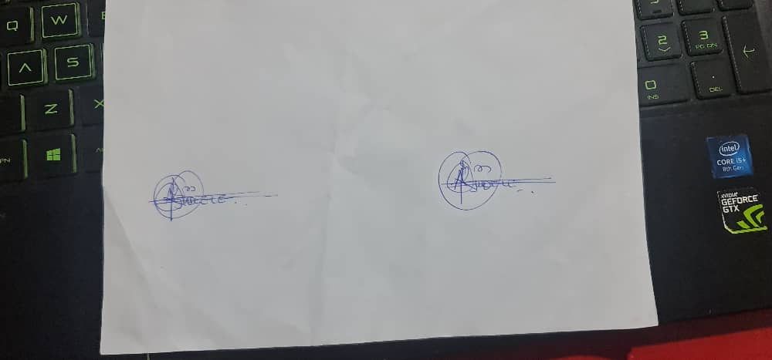
________________________ _______________________
SIGNATURE OF SUPERVISOR SIGNATURE OF STUDENT
INTRODUCTION

Background to the Study
Level measurement has seen considerable change over the past decades – from purely mechanical level measurement through to complex electronic sensors using various measuring principles. The large number of different technologies for measuring level (such as hydrostatic, reed chain, magneto resistivity, radar, ultrasound, optical and many more) today offers the user the possibility to choose the most suitable sensor technology for his individual application (Dong, & Zhang, 2012). In continuous level measurement, hydrostatic pressure (also known as hydrostatic level measurement) is the principal sensor technology and measuring principle, with a market share of approximately 40 %1 by sales volume. Still considerably ahead of ultrasound and radar technologies, hydrostatic sensors for level measurement are installed in more than every second measuring point. Thus, the immense importance of this technology is reflected in its steady growth from US$ 650 M in the pre-crisis year of 2008, to around US$ 770 M in 20131.
The typical process plant contains many tanks, vessels, and reservoirs. The main function of these containers is to store or process materials. Accurate measurement of the contents of these containers is very vital. Usually, the material in the tanks is liquid whose level must be accurately measured. It is with this and more convenience that this project was developed.
Today the Internet has become ubiquitous, has touched almost every corner of the globe, and is affecting human life in unimaginable ways. However, the journey is far from over. We are now entering an era of even more pervasive connectivity where a very wide variety of appliances will be connected to the web. We are entering an era of the “Internet of Things” (abbreviated as IoT). This term has been defined by different authors in many different ways (Gubbi, Buyya, Marusic, & Palaniswami, 2013). Let us look at two of the most popular definitions. Vermesan et al. define the Internet of Things as simply an interaction between the physical and digital worlds. The digital world interacts with the physical world using a plethora of sensors and actuators. Another definition by Peña-López et al. Defines the Internet of Things as a paradigm in which computing and networking capabilities are embedded in any kind of conceivable object. We use these capabilities to query the state of the object and to change its state if possible. In common parlance, the Internet of Things refers to a new kind of world where almost all the devices and appliances that we use are connected to a network. We can use them collaboratively to achieve complex tasks that require a high degree of intelligence.
For this intelligence and interconnection, IoT devices are equipped with embedded sensors, actuators, processors, and transceivers. IoT is not a single technology; rather it is an agglomeration of various technologies that work together in tandem.
The storage and processing of data can be done on the edge of the network itself or in a remote server. If any preprocessing of data is possible, then it is typically done at either the sensor or some other proximate device. The processed data is then typically sent to a remote server. The storage and processing capabilities of an IoT object are also restricted by the resources available, which are often very constrained due to limitations of size, energy, power, and computational capability. As a result, the main research challenge is to ensure that we get the right kind of data at the desired level of accuracy. Along with the challenges of data collection, and handling, there are challenges in communication as well. The communication between IoT devices is mainly wireless because they are generally installed at geographically dispersed locations. The wireless channels often have high rates of distortion and are unreliable. In this scenario reliably communicating data without too many retransmissions is an important problem and thus communication technologies are integral to the study of IoT devices.
Justification for the Study
Hydrostatic pressure measurement is suited for level measurement due to the hydrostatic effect of non-flowing fluids (Dong, & Zhang, 2012). This physical principle describes the effect of the weight force of a stationary, meaning non-flowing, liquid on a measuring point. The most important condition for hydrostatic level measurement is what is called the “hydrostatic paradox.” This means that, regardless of the shape and volume of a vessel, the hydrostatic pressure at the measuring point of a tank or vessel is proportional only to the filling height. Thus, despite the apparent contradiction of an over-proportional increase or decrease in the volume or weight of a liquid with change in height, the hydrostatic pressure at the measuring point is solely proportional to the absolute filling height, and not to the filling quantity.
In hydrostatic level measurement in open or vented basins or vessels, a continuous pressure compensation of the ambient air with the gas phase above the liquid takes place. Thus the ambient pressure that acts on the medium as an additional “force” always resembles the ambient pressure acting on the whole system, including the level sensor. If one therefore uses a pressure sensor with a relative pressure measuring cell, a pressure sensor that is compensated or vented (just like the tank) to the ambient pressure, it “automatically” compensates for the effect of this ambient pressure on the level measurement. This means that a relative pressure sensor in vented vessels and tanks completely “cancels out” the atmospheric pressure overlying on the liquid from the level measurement. Thus, the hydrostatic pressure corresponds only to the filling height of the liquid.
The level measurement in sealed, gas-tight vessels, which is frequently found in the chemical industry, requires a compensation of the pressure of the enclosed gas phase above the liquid (Dong, & Zhang, 2012). The enclosed pressure of the gas phase acts as an additional force on the liquid and distorts any hydrostatic pressure measurement at the base of the vessel. Thus, this distorting influence must be compensated through an additional pressure measurement of the gas phase. Frequently, a second pressure sensor is used for the measurement of the gas pressure. This application effectively represents a differential pressure measurement, where the two separate pressure
Measurements are offset against each other. This offset calculation can be made either by two individual sensors or via an integrated differential pressure sensor. In this application, the sensors used can either be relative (sensor with ambient pressure compensation) or absolute pressure variants (sensor with sealed vacuum reference) (Clote, Malekian, &Nair, 2016). Bubblers, differential pressure transmitters and displacers are all different hydrostatic measurement devices. Changes in temperature cause a change in a liquid's the specific gravity of the liquid; similarly changes in pressure also affect the specific gravity of the vapor that is present over the liquid. As a result of these changes, the accuracy of the measurement is reduced. Displacers are based on the Archimedes principle.
The density of the displacer is always more than that of the process fluid, so that it extends from the lowest level of the tank to the highest level that needs to be measured. The column displaces a volume of the fluid due to a rise in the process fluid; the displaced volume is equal to the product of cross-sectional area of the column and the level of process fluid in the displacer. A buoyant force, whose magnitude is equal to the product of the displaced volume and the process fluid density, exerts an upward thrust on the displacer, which brings down the force required to support it against the gravitational force. This change is monitored by the transducer linked to the transmitter, and translates the change in force to level.
The bubbler method is used in vessels that work under atmospheric pressure. A purge gas is carried in a dip tube with its open end near the opening of the vessel into the tank. The purge gas is usually air, but in some cases where there is danger of an oxidative reaction with the process fluid or contamination, dry nitrogen is used. Due to the flow of gas through the dip tube outlet, the tube pressure rises till it is more than the hydrostatic pressure generated by the liquid level at the outlet. The product of the process fluid density and its depth from the end of the dip tube to the surface is equal to the pressure, which is monitored by a pressure transducer connected to the tube. In this sensor, the difference between the total pressure at the bottom of the tank and the head or static pressure in the vessel is indicative of the level. Similar to the bubbler method, the product of the fluid density and the height of the fluid in the vessel gives the hydrostatic pressure difference. Atmospheric pressure is considered as reference. In order to maintain headspace at atmospheric pressure a vent is provided at the top. Unlike bubblers, DP sensors can be used in vessels by simply connecting the reference port to a port in the vessel, which is above the maximum fill level. The need for liquid purges or bubblers depends on the physical conditions of the process and/or the location of the transmitter with respect to process connections.
Kashyap (2015) design a low cost multi-channel data acquisition system for meteorological application. The primary objective of the present work is to design a low-cost multi-channel data acquisition system which can be used for meteorological application. The proposed multi-channel data acquisition system acquires ambient temperature, barometric pressure, altitude, humidity and light intensity data from environment and stores the data for future use. The sensors are connected with a low-cost microcontroller (ATmega328) unit which performs the data acquisition and data logging operation. A real time clock is used to keep current time with the measurement. Different communication interfaces such as serial communication, wireless communication and Ethernet communication are used in the data acquisition system. In serial communication, the sensor data are logged in COM port of PC. LabVIEW based application is developed which provides graphical user interface for the user. VISA protocol is used to communicate the COM port data with LabVIEW. Other communication protocol such as wireless communication and Ethernet communication protocol is used to transmit the sensor data over a communication channel. The data is uploaded in Ethernet which can be viewed using a web browser. In wireless communication Xbee transmitter and Xbee receiver modules are used to transmit data over a longer distance. The salient features of this developed system is that the system is low cost, uses open source software’s like Arduino and python and the system is economical (i.e. INR 6500). This developed system performs satisfactorily under different condition. The system is tested for 24 hours in April 2015 and provides satisfactory results.
Gurjar (2015) developed a Bluetooth based data acquisition system. The data acquisition systems are devices used to collect information to document or analyse some physical phenomenon such as voltage, force or temperature. Data acquisition systems available in the market are very expensive, bulky and power hungry. However, PC based data acquisition system offers a lot of benefit in terms of processing speed, display resolution and connectivity capabilities. The Project aims at designing and implementing a portable, economical and power efficient real-time data acquisition system. The proposed system comprises of a hardware circuitry and a Graphical User Interface (GUI) based on MATLAB environment. The hardware device consists of an 8-bit microcontroller interfaced with a serial ADC chip and a Bluetooth serial module. The Bluetooth HC-05 module is used to provide a wireless connectivity between the hardware and the PC. For testing purpose, the sampling rate of ADC is set to 833 Hz, capturing 50 values per 0.06 second. Whereas on the PC side, the GUI receives the sampled values transmitted by the hardware device and plots the real-time signal waveform. It has been found that the GUI plots the signal waveform with good quality and efficiency. The proposed system can be deployed in number of industrial applications such as remote device controlling and ECG data acquisition with some adjustments in the hardware. The wireless connectivity reduces the complexity of cables and probability of occurrences of the accidents in industrial areas.
Yahaya (2015) developed a real-time measurement and monitoring system using Zigbee and labview. Wireless communication technologies become popular in real-time industrial environments. This project describes the fundamental work of real time measurement and monitoring system with Arduino, ZigBee, and Graphical Programming language (LabVIEW). Thickness of the item is taken as a parameter that will convert into the number of items. By acquiring the analogue data from the ultrasonic sensor, the suitable signal conditional is fed to Arduino. It is connected to the ZigBee transmitter module, which transmits the data to the ZigBee receiver. As a result, the data received will be viewed on a PC via LabVIEW. The methodology describe in the proposed work is useful for designing Wireless Sensor Network (WSN) system in the industrial application such as real levelling storage. The experimental of transmission range and observation of data required in LabVIEW was reported. The combination of measurement, wireless transmission and monitoring system can be improved of accuracy of measurement, especially for sustainability of better working place.
Makanjuola, Shoewu, Akinyemi, & Ajasa (2018) design and developed a microcontroller based liquid level detector with graphical output. This paper presents and discusses the design and construction of a microcontroller-based liquid level detector with graphical output. This was achieved using a programmable microcontroller and some additional components, including a pumping machine. This project was done with the use of a 220V AC power supply which was stepped down to 12V AC via a transformer. A switch was added as a protective device to break the power supply in case of a bridge or short circuit. A voltage regulator was incorporated to convert the incoming AC voltage to DC voltage, as 5V DC is needed by the microcontroller to execute its work. The microcontroller responds to the program written through the MAX 232. The PC at the last stage of the design shows the status of the indicator probes at various levels of water. The PC also shows the levels of water in percentage (10%, 15%, 25%, 50%, 75% and 100%) when the pumping machine began to transport water from the first probe to the last probe. The system is applicable in industry and for residential use to avoid spillage of liquid (hazardous or otherwise) to the environment.
Objective of the Study
The overall aim of this study is the design and implementation of an automatic level rig using hydrostatic pressure interfaced with internet of things.
The specific objectives are:
- Continuous monitoring of any liquid – Water stored in a container OR a lake or pond, Chemical – stored in big containers in Industries.
- These monitoring can be either to calculate the usage OR to keep a check on leakage as well as theft detection.
- Since, the project uses IOT; the liquid level monitoring can be done from any remote place.
- To incorporate an interactive medium between the end user and the machine.
ternet of Things (IoT) is widely used as a survive technology and its makes things
interconnected utilizing the internet as a backbone. IoT used in many ﬁelds including
E-Health, Smart Metering, Security and Emergencies, Logistics, Industrial Control,
Retail, Agriculture, Farming, Home Automation, and Smart Cities [1]. Many IoT
Systems are real-time systems (RTSs) which depend on Real Time Operating Systems
(RTOSs). RTOS is an Operating System for embedded real-time systems; it is used for
its essential features such as; reliability, modularity, predictability, compact, and high
performance [2]. RTOS provides multi-tasking and introduces many services; task
management, memory management, and time management. For all mentioned features
for the RTOS, it should be used in the IoT Platforms. The researchers that use the
RTOS formed many research directions, such as; in IoT implementations, IoT
frameworks proposing, IoT protocols performance evaluation, IoT RTOS Picking, and
RTOS Adapting to work with IoT [3]. Some of IoT researchers are targeting a platform
for the IoT, but most of them aren’t suitable for real-time systems where time is critical,
and it were done for speciﬁc applications, its used a ready-made communication
protocol such as the MQTT protocol. In this paper, a design and implementation for an
IoT Platform will be proposed for general applications and the critical applications, its
Internet of Things (IoT) is widely used as a survive technology and its makes things
interconnected utilizing the internet as a backbone. IoT used in many ﬁelds including
E-Health, Smart Metering, Security and Emergencies, Logistics, Industrial Control,
Retail, Agriculture, Farming, Home Automation, and Smart Cities [1]. Many IoT
Systems are real-time systems (RTSs) which depend on Real Time Operating Systems
(RTOSs). RTOS is an Operating System for embedded real-time systems; it is used for
its essential features such as; reliability, modularity, predictability, compact, and high
performance [2]. RTOS provides multi-tasking and introduces many services; task
management, memory management, and time management. For all mentioned features
for the RTOS, it should be used in the IoT Platforms. The researchers that use the
RTOS formed many research directions, such as; in IoT implementations, IoT
frameworks proposing, IoT protocols performance evaluation, IoT RTOS Picking, and
RTOS Adapting to work with IoT [3]. Some of IoT researchers are targeting a platform
for the IoT, but most of them aren’t suitable for real-time systems where time is critical,
and it were done for speciﬁc applications, its used a ready-made communication
protocol such as the MQTT protocol. In this paper, a design and implementation for an
IoT Platform will be proposed for general applications and the critical applications, its
Internet of Things (IoT) is widely used as a survive technology and its makes things
interconnected utilizing the internet as a backbone. IoT used in many ﬁelds including
E-Health, Smart Metering, Security and Emergencies, Logistics, Industrial Control,
Retail, Agriculture, Farming, Home Automation, and Smart Cities [1]. Many IoT
Systems are real-time systems (RTSs) which depend on Real Time Operating Systems
(RTOSs). RTOS is an Operating System for embedded real-time systems; it is used for
its essential features such as; reliability, modularity, predictability, compact, and high
performance [2]. RTOS provides multi-tasking and introduces many services; task
management, memory management, and time management. For all mentioned features
for the RTOS, it should be used in the IoT Platforms. The researchers that use the
RTOS formed many research directions, such as; in IoT implementations, IoT
frameworks proposing, IoT protocols performance evaluation, IoT RTOS Picking, and
RTOS Adapting to work with IoT [3]. Some of IoT researchers are targeting a platform
for the IoT, but most of them aren’t suitable for real-time systems where time is critical,
and it were done for speciﬁc applications, its used a ready-made communication
protocol such as the MQTT protocol. In this paper, a design and implementation for an
IoT Platform will be proposed for general applications and the critical applications, its

RESEARCH METHODS
The research methodology of this research work entails calculations, component selection and design specification before the actual implementation. The design was divided into the following units for simplicity and efficiency according to the block diagram (Fig. 1).
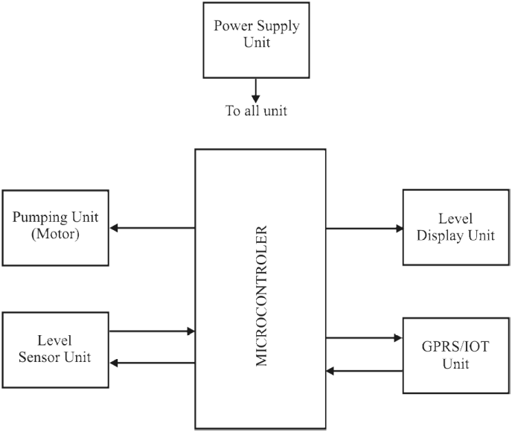
Fig. 1. Automatic level rig using hydrostatic pressure interfaced with IOT
- The Pump Unit: This unit represents the 220V AC Water Pump that lifts the process (water) from the storage tank into the process reservoir.
- Level Sensor: The level sensor is hydrostatic level sensor; it is a submersible pressure transmitter that has a pressure diaphragm where the inner side of the diaphragm is vented to atmospheric pressure through a vent tube in the cable and the outer side is in contact with the liquid and measuring the static pressure of the liquid column above the transmitter. This static pressure is basically caused by the weight of the fluid on top of the transmitter and is used to calculate the level of the liquid.
- Microcontroller: The microcontroller (PIC16F84) takes the digital signals from the output of the analogue to digital converter (ADC), processes it and displays the value on the display circuit.
- The internet of things, or IoT, is a system of interrelated computing devices, mechanical and digital machines, objects, animals or people that are provided with unique identifiers (UIDs) and the ability to transfer data over a network without requiring human-to-human or human-to-computer interaction.
- Display: the display used for this design is the liquid crystal display (LCD). It displays whatever has been processed by the micro controller and the display shows when the processes are above or below the set point on the liquid crystal display (LCD).
- Power supply unit: the power supply unit provides the needed voltage for the circuit to operate. Power supply is basically made up of the transformer, rectification circuit, smoothing circuit and a voltage regulation circuit.
Internet of Things (IoT) is widely used as a survive technology and its makes things
interconnected utilizing the internet as a backbone. IoT used in many ﬁelds including
E-Health, Smart Metering, Security and Emergencies, Logistics, Industrial Control,
Retail, Agriculture, Farming, Home Automation, and Smart Cities [1]. Many IoT
Systems are real-time systems (RTSs) which depend on Real Time Operating Systems
(RTOSs). RTOS is an Operating System for embedded real-time systems; it is used for
its essential features such as; reliability, modularity, predictability, compact, and high
performance [2]. RTOS provides multi-tasking and introduces many services; task
management, memory management, and time management. For all mentioned features
for the RTOS, it should be used in the IoT Platforms. The researchers that use the
RTOS formed many research directions, such as; in IoT implementations, IoT
frameworks proposing, IoT protocols performance evaluation, IoT RTOS Picking, and
RTOS Adapting to work with IoT [3]. Some of IoT researchers are targeting a platform
for the IoT, but most of them aren’t suitable for real-time systems where time is critical,
and it were done for speciﬁc applications, its used a ready-made communication
protocol such as the MQTT protocol. In this paper, a design and implementation for an
IoT Platform will be proposed for general applications and the critical applications, its
Internet of Things (IoT) is widely used as a survive technology and its makes things
interconnected utilizing the internet as a backbone. IoT used in many ﬁelds including
E-Health, Smart Metering, Security and Emergencies, Logistics, Industrial Control,
Retail, Agriculture, Farming, Home Automation, and Smart Cities [1]. Many IoT
Systems are real-time systems (RTSs) which depend on Real Time Operating Systems
(RTOSs). RTOS is an Operating System for embedded real-time systems; it is used for
its essential features such as; reliability, modularity, predictability, compact, and high
performance [2]. RTOS provides multi-tasking and introduces many services; task
management, memory management, and time management. For all mentioned features
for the RTOS, it should be used in the IoT Platforms. The researchers that use the
RTOS formed many research directions, such as; in IoT implementations, IoT
frameworks proposing, IoT protocols performance evaluation, IoT RTOS Picking, and
RTOS Adapting to work with IoT [3]. Some of IoT researchers are targeting a platform
for the IoT, but most of them aren’t suitable for real-time systems where time is critical,
and it were done for speciﬁc applications, its used a ready-made communication
protocol such as the MQTT protocol. In this paper, a design and implementation for an
IoT Platform will be proposed for general applications and the critical applications, its
Internet of Things (IoT) is widely used as a survive technology and its makes things
interconnected utilizing the internet as a backbone. IoT used in many ﬁelds including
E-Health, Smart Metering, Security and Emergencies, Logistics, Industrial Control,
Retail, Agriculture, Farming, Home Automation, and Smart Cities [1]. Many IoT
Systems are real-time systems (RTSs) which depend on Real Time Operating Systems
(RTOSs). RTOS is an Operating System for embedded real-time systems; it is used for
its essential features such as; reliability, modularity, predictability, compact, and high
performance [2]. RTOS provides multi-tasking and introduces many services; task
management, memory management, and time management. For all mentioned features
for the RTOS, it should be used in the IoT Platforms. The researchers that use the
RTOS formed many research directions, such as; in IoT implementations, IoT
frameworks proposing, IoT protocols performance evaluation, IoT RTOS Picking, and
RTOS Adapting to work with IoT [3]. Some of IoT researchers are targeting a platform
for the IoT, but most of them aren’t suitable for real-time systems where time is critical,
and it were done for speciﬁc applications, its used a ready-made communication
protocol such as the MQTT protocol. In this paper, a design and implementation for an
IoT Platform will be proposed for general applications and the critical applications, its
EXPECTED FINDINGS
At the end of this study, the following could be expected:
- A system whereby accurate level measurement is gotten.
- Automatically controlled pump which ensures constant reserve of water in the tank
- The scope of the design was kept concise and simple in order not to introduce unnecessary complexities and render.
- A successful attempt has been made to design a Real time level control system using locally available material. The system will be capable of enhancing level measurement and control.
- The design will be implemented using embedded system technology and internet technology. This is to reduce component count, keep the system simple and cost effective.
EXPECTED CONTRIBUTION TO KNOWLEDGE
The study could contribute to knowledge in the following ways:
- In the system’s remote control.
- In the system’s automation and storage which is a new technology
- In the system’s accurate level sensing resulting in the ON and OFF of the pump.
- The mode of communication.
- Only a single person can manage multiple control system.

REFERENCES
Ahuja, D. & Chaudhary, N. (2012), Programmable Logic Controller International Journal of Information and Computer Science, 1: 115-120
AN Ning, AN Yu (2010). A monitoring system for water quality", IEEE International Conference on Electrical and Control Engineering, 4615- 4617.
Dong He, Li-Xin Zhang (2012). The water quality monitoring system based on WSN", IEEE International Conference on Consumer Electronics, Communication and Networks, 3661-3664.
Gubbi, J., Buyya, R., Marusic, S., Palaniswami, M (2013). Internet of Things (IoT): A vision, architectural elements, and future directions. Future Generat.Comput. Syst. 29(7), 1645– 1660
Happ, D., Karowski, N., Menzel, T., Handziski, V., Wolisz, A. (2017). Meeting IoT platform requirements with open pub/sub solutions. In: Annals of Telecommunications. Springer
Lambrou, T. Anastasiou, C. Panayiotou, C. and Polycarpou, M. (2014). A low-cost sensor network for real- time monitoring and contamination detection in drinking water distribution systems", IEEE Sen- sors Journal, 14 (8), 2765-2772.
Muhammad Azwan Nasirudin, Ummi Nusulhaiza zabah,O.sidek (2011). Fresh water real time monitor- ing system based on wireless sensor network and GSM", IEEE Conference on open systems, 354- 357.
Niel Andre Clote, Reza Malekian, Lakshmi Nair (2016). Design of smart sensors for real time water quality monitoring," IEEE Journal, 4 (9): 3975- 3990.
Park, K., Kim, S. (2015): Design of mainframe for IoT framework. In: International Conference on u- and e-Service, Science and Technology.

